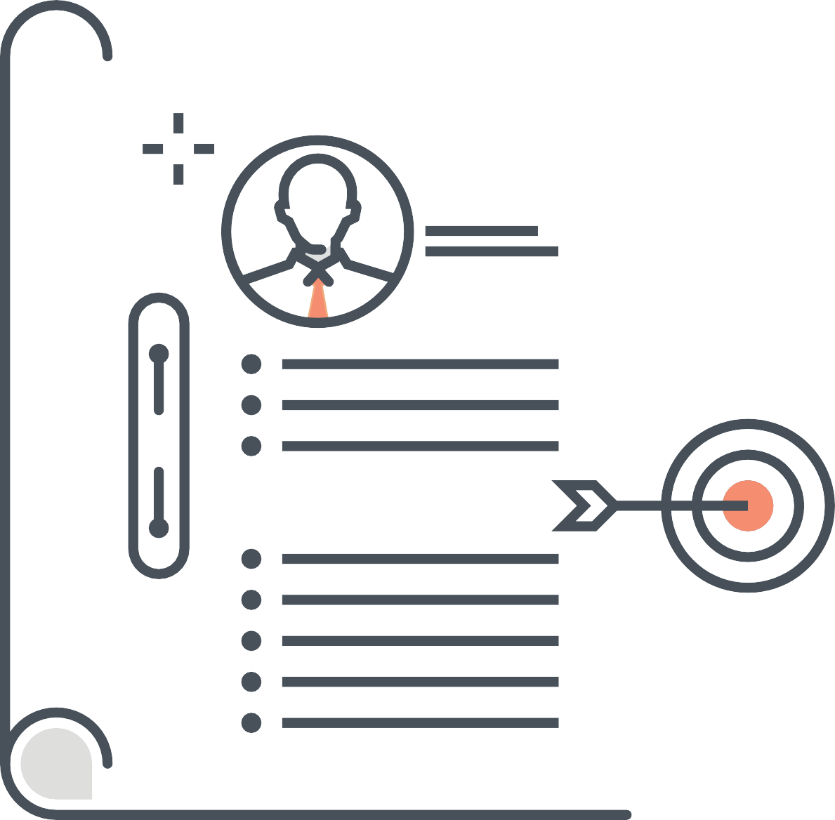
• -I - • I •
I
- -
I

Company Profile Template -
•

• •
-I -
I

I I
-
•
-

Company Profile Template
As you’ve seen in this article from IMPACT, your company profile can be as simple or elaborate as you like.

This template will outline all of the basic information you should include, but when designing your document or page, remember your audience and what they would want to see and read. Most importantly, stay true to your brand!

Company Information and Contact Details

- Business Name:
Edit Field

- Mailing Address: Edit Field
- Phone: Edit Field
- Email: Edit Field
- Website: Edit Field
- Business Type: Sole proprietor, closed corporation, private company, company, trust.
- Annual Revenue: Edit Field

- Total Number of Employees:
Edit Field

- Primary Line of Business: Edit Field
- Primary Audience: Edit Field

Leadership/Management Team

- Name, Job Title
- Name, Job Title
- Name, Job Title

Company Overview

Brief History:

In 1-2 brief paragraphs, describe how your organization was founded.

Summary of Primary Offering:

Describe your primary line of business; what generates revenue for your organization?

- Products
- Services

Edit Field Edit Field

- Pricing Structure
Edit Field

Details:

Purpose:

Describe your organization’s reason for existing; your overarching goal that goes beyond specific products or services.

- Vision: Outlines what an company wants to be long-term. It focuses on the future; it is inspirational; it provides clear decision-making criteria; and it is doesn’t change over time.

Mission statement:

Outlines what the company is now. It focuses on today; it identifies the customer(s); it identifies the critical process(es); and it states the level of performance.

- Core values: Guiding qualities that guide all of your activities.
- Goals: Specific goals that your company wants to achieve.

Audience Overview:
Who is your audience? In 1-2 paragraphs, describe your buyer and their demographics.

Workforce

Similar to your audience, briefly describe your workforce. How many team members do you employ? What are their skill sets? Qualifications? Education?

Key Processes

Does you use any unique or patented processes? Introduce them here.

Company Achievements/News

Recount your company’s most impressive achievements and any important news. (i.e. an acquisition, awards, new certifications, etc.)

Present Conditions

Briefly summarize your organization and business as it stands is today. What does your team look like? What are your strengths, weaknesses, or external barriers? You want to leave readers with a clear, factual, but positive outlook on your business and future.

Need Help Building Your Company Profile or a Full Website Redesign?
Talk to IMPACT about redesigning your website on the HubSpot Website Platform.


